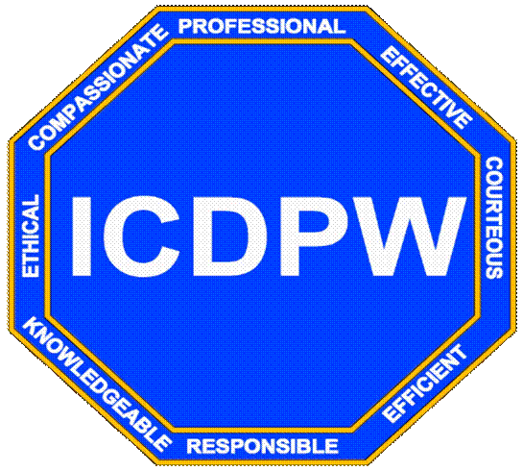

COUNTY OF Imperial County
DEPARTMENT OF PUBLIC WORKS
155 S. 11th Street, El Centro, CA 92243

CAPITAL PROJECT REQUEST FORM

ATTENTION: Please submit the completed form to marcelocortes@co.imperial.ca.us and gracielaalvarez@co.imperial.ca.us.

DEPARTMENT INFORMATION:
Date Submitted: |  |  | Account No.:
Department: |  |  | Funding Source for Project Processing:
Contact Person: |  |  | If Available Matching Funds Source:
Phone: |  |  |  | Amount Available: |  |  |  | Account No.:
Email Address: |  |  | Department Head Approval:
 |  |  |  |  |  | Signature
Please Note: The contact person(s) shall be the only individual, aside from the Department Head,
to give direction and make decisions, unless otherwise requested.

pROJECT LOCATION:

pROJECT DESCRIPTION: (Include scope of work, any future project phases and/or ancillary projects, and alternatives considered, if appl.)

PROJECT IMPROVEMENTS/RECONSTRUCTION/ALTERATIONS: (Select all that are appl.)
 | ADA Compliance |  | New Data Drops |  | New Office(s)/Area(s) |  | Other:
 | Addition |  | New Construction |  | Remodel |  | Other:
 | Doors |  | New Electrical |  | New Window(s) |  | Other:
 | Exterior Improvements |  | New Equipment |  | New Flooring |  | Other:
 | HVAC |  | New Furniture |  | Repaint |  | Other:
 | Replace Equipment |  | New Walls |  | Building Assessment |  | Other:

JUSTIFICATION of need: (Describe program requirement, need and/or benefits of project and any impact of deferral)

SPECIAL REQUIREMENTS: (Project schedule, start and end dates, funding requirements and restrictions, etc...)
If Grant Project: |  | Federal Funding |  | Amount Available: |  |  |  | State Funding | Amount Available:
Sheet 2 of 2 |  |  | CAPITAL PROJECT REQUEST FORM

For use by the CEO’s Office:
Date: |  |  |  |  |  | CEO Approval Signature:
Project Priority: |  |  |  |  | High |  | Normal |  |  | Low
Action Requested from Public Works (please check all appl. actions):
 | Prepare a general scope and definition of the proposed project. Include preliminary impressions of feasibility, costs, range, timing constraints, and any other information useful to the CEO’s Office.
 | Provide project assessment including architectural and engineering analysis and preliminary cost assessment.
 | Construction project management team, if any.
 | No action shall be taken at this time.
Additional Direction(s):

PROJECT DISTRIBUTION LIST: (Departmental Review)
DEPARTMENT | DATE SUBMITTED | REVIEWED BY | INITIALS | DATE | ACTION |  |  |  |  |  | COMMENT(S)
 |  |  |  |  | Proceed |  | Hold |  | None |  | COMMENT(S)
 |  |  |  |  | YES | NO | YES | NO | YES | NO | COMMENT(S)
GSA
Risk Management
County Counsel
PW Facilities
ITS
Purchasing
Air Pollution
Clerk of the Board
PW Accounting

